Objective Questions

- Does any table have missing values or duplicates? If yes how would you handle it ?
The Chinook database contains a total of 11 tables. To identify the missing or null values we are using CASE statement here and to find out the duplicates will check the data using GROUP BY clause those HAVING count greater than 1
SELECT COUNT(*) AS total_rows,
SUM(CASE WHEN album_id IS NULL THEN 1 ELSE 0 END) AS null_album_id,

SUM(CASE WHEN title IS NULL THEN 1 ELSE 0 END) AS null_title,
SUM(CASE WHEN artist_id IS NULL THEN 1 ELSE 0 END) AS null_artist_id,
(SELECT COUNT(*) FROM (SELECT album_id FROM album GROUP BY album_id HAVING COUNT(*) > 1) AS duplicate) AS duplicate_album_id
FROM album

Here is the snapshot of the query along with the output.
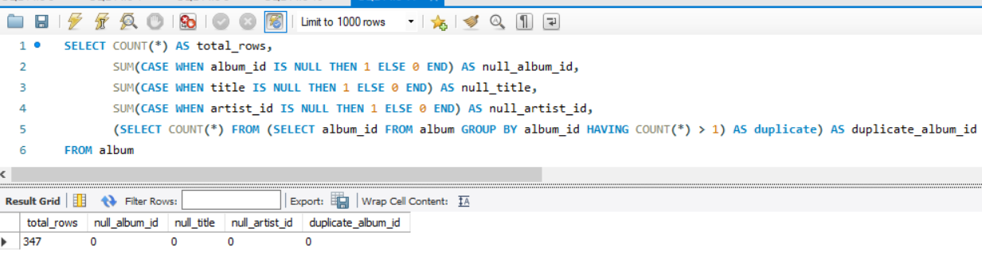
Similarly, we have reviewed all the tables and found below ones having missing values and there are no duplicates found.
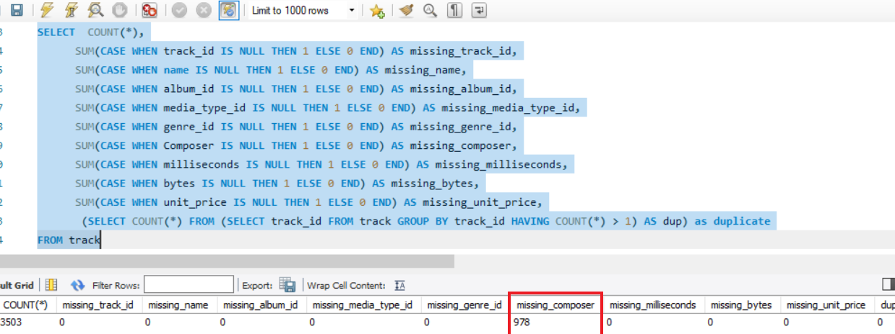

Here is the data indicating the tables containing missing and duplicate

Table Name | Data Description
Customer | 49 records are missing in Company column  29 records are missing in State column  4 postal code records are missing  1 phone missing  47 fax values are missing
Employee | 1 record is NULL/missing in reports_to column
Track | 978 records are missing in Composer column

- Find the top-selling tracks and top artists in the USA and identify their most famous genres.
To find out top-selling tracks and top artists in the UAS along with their famous genre we will have to use below tables:
- track - to get track names
- artist - to get artist name
- genre - to get genre names
- album - to get artist
- invoice - to filter sales in the USA
- invoice_line - to calculate quantity sold
SELECT t.name AS track_name, ar.name AS artist_name, g.name AS genre_name, SUM(il.quantity) AS total_units_sold
FROM invoice i
JOIN invoice_line il ON i.invoice_id = il.invoice_id
JOIN track t ON il.track_id = t.track_id
JOIN album al ON t.album_id = al.album_id
JOIN artist ar ON al.artist_id = ar.artist_id
JOIN genre g ON t.genre_id = g.genre_id
WHERE i.billing_country = 'USA'
GROUP BY t.track_id
ORDER BY total_units_sold DESC LIMIT 5;

By performing JOIN operation on above listed table we can get top-selling tracks in USA, their respective artist, and genre of those tracks
Here is the snapshot of code and its output:
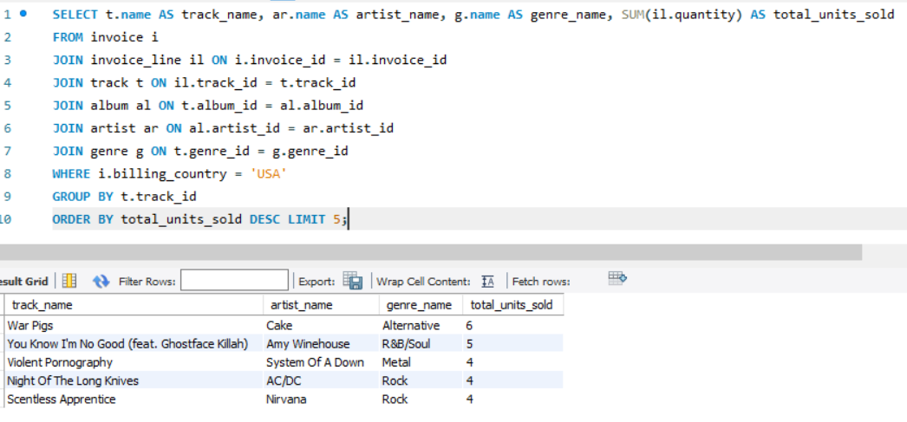

- What is the customer demographic breakdown (age, gender, location) of Chinook's customer base?
The Chinook database does not store age or gender in the Customer table, only location and contact information like first & last name, company, address, city, state email, country, city, etc as mentioned in below snapshot.
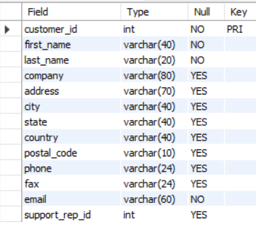
While demographic details like age and gender are not available, we can still analyze the customer base by grouping records by Country to see the distribution across different locations .
SELECT country, COUNT(*) AS customer_count
FROM customer
GROUP BY country
ORDER BY customer_count DESC;

Here is the o/p of query:
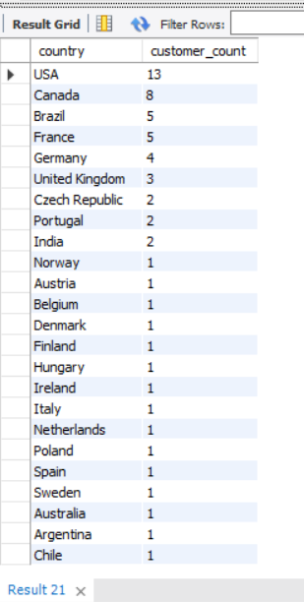

- Calculate the total revenue and number of invoices for each country, state, and city:
In the Chinook database, the invoice table contains billing_country, billing_state, billing_city. By executing below query we can get the total revenue and number of invoices for each country, state, and city
- Total revenue and number of invoices by each country:
SELECT billing_country, count(invoice_id) as Number_of_invoices, sum(total) as Total_Revenue
FROM invoice
GROUP BY billing_country
ORDER BY Total_Revenue desc;

Here is the o/p of query:
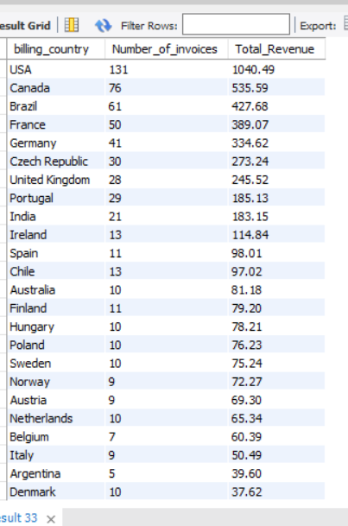
- Total revenue and number of invoices by each city:
SELECT billing_city, count(invoice_id) as Number_of_invoices, sum(total) as Total_Revenue
FROM invoice
GROUP BY billing_city
ORDER BY Total_Revenue desc;

Here is the o/p of query:
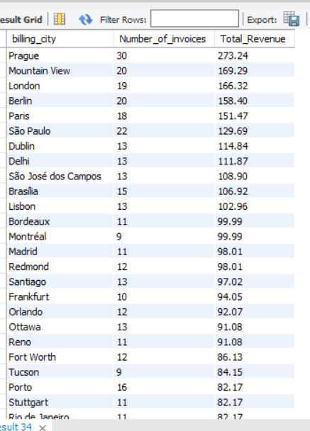
- Total revenue and number of invoices by each sate:
SELECT billing_state, count(invoice_id) as Number_of_invoices, sum(total) as Total_Revenue
FROM invoice
GROUP BY billing_state
ORDER BY Total_Revenue desc;

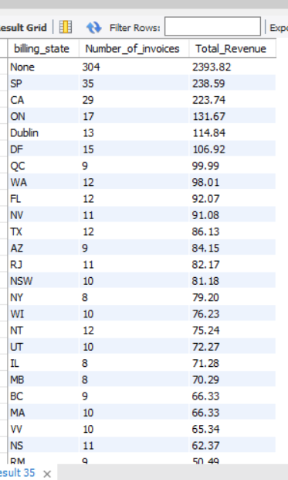

- Find the top 5 customers by total revenue in each country
To identify 5 customers by total revenue in each country we have to use customer and invoice tables:
- join on customer and invoice table on customer_id
- then calculate SUM(total) per customer per country
- using ROW_NUMBER() we will get top 5 per country
- Filter to only top 5 using a CTE or subquery
Here is the query:
with revnue_by_country as (
select c.customer_id, c.first_name, c.last_name, i.billing_country, sum(i.total) as Total_Revenue,
row_number() over (partition by i.billing_country order by sum(i.total) desc) as revenue_rnk
from invoice i
join customer c on i.customer_id = c.customer_id
group by i.customer_id, i.billing_country, c.first_name, c.last_name
)
select customer_id as CustomerId, first_name as FirstName, last_name as LastName, billing_country as BillingCountry , Total_Revenue
from revnue_by_country where revenue_rnk <=5
order by billing_country, revenue_rnk;

Here is the query o/p:
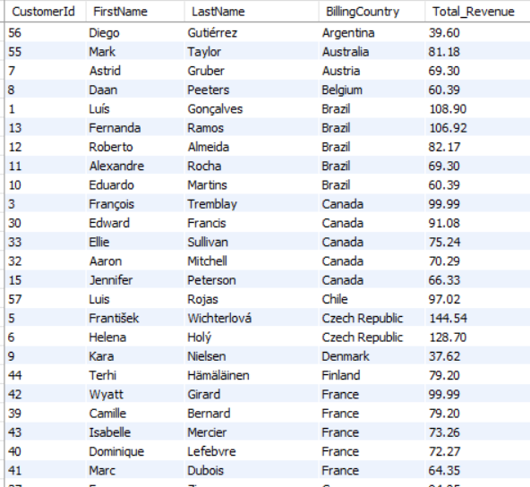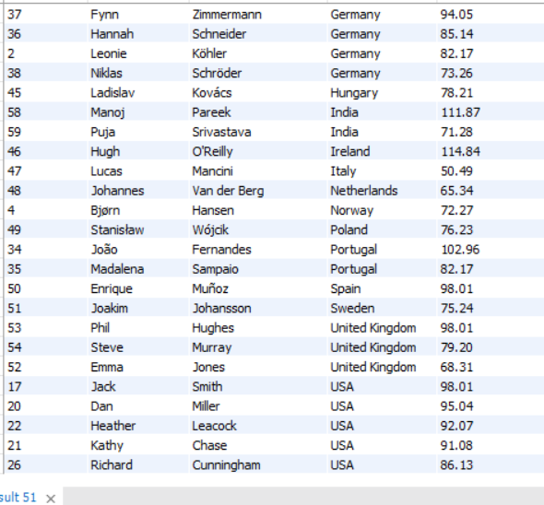

- Identify the top-selling track for each customer
To identify the top selling track for each customer we have to customer, invoice, invoice_line, track tables
WITH customer_track_sales AS (
SELECT c.customer_id, c.first_name, c.last_name, t.track_id, t.name AS track_name, SUM(il.quantity) AS total_units, sum(i.total) as total_revenue,
ROW_NUMBER() OVER (PARTITION BY c.customer_id ORDER BY SUM(il.quantity) DESC) AS rnk
FROM customer c
JOIN invoice i ON c.customer_id = i.customer_id
JOIN invoice_line il ON i.invoice_id = il.invoice_id
JOIN track t ON il.track_id = t.track_id
GROUP BY c.customer_id, c.first_name, c.last_name, t.track_id, t.name, i.total
)
SELECT customer_id, first_name, last_name, track_name, total_units,total_revenue
FROM customer_track_sales WHERE rnk = 1
ORDER BY total_units desc;

Here is the o/p of query:
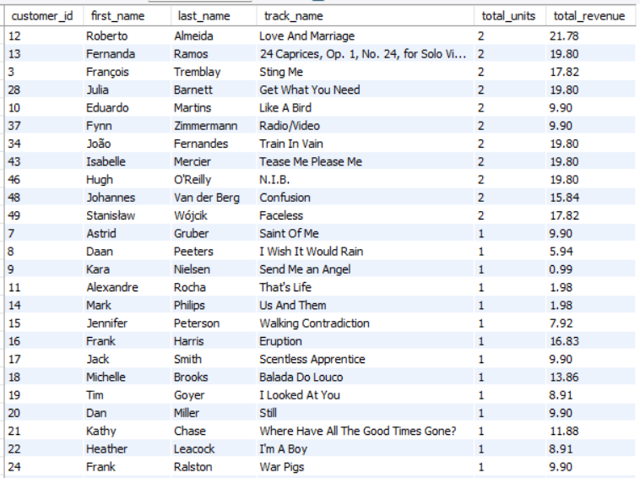

- Are there any patterns or trends in customer purchasing behavior (e.g., frequency of purchases, preferred payment methods, average order value)?
In the given dataset the payment method is not mentioned in any of the transaction/invoice or customer tables hence we cant identify the preferred payment methods.
However, we can count the number of invoices per customer to know the frequency of purchases by executing below query:
SELECT c.customer_id, c.first_name, c.last_name, COUNT(i.invoice_id) AS total_purchases
FROM customer c
JOIN invoice i ON c.customer_id = i.customer_id
GROUP BY c.customer_id, c.first_name, c.last_name
ORDER BY total_purchases DESC;

Refer to the o/p of query in below snapshot:

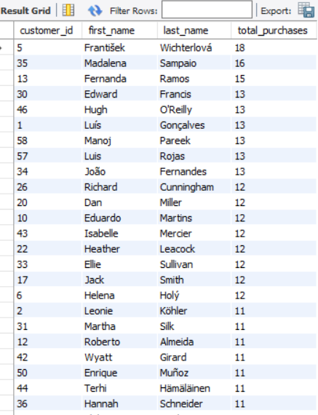
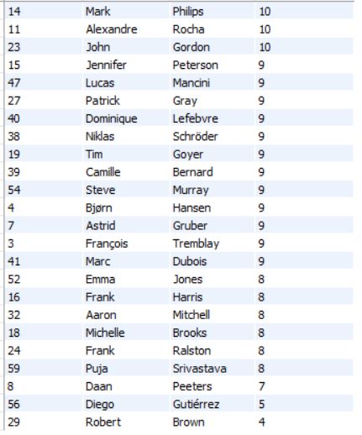
Now lets see the average order value by joining customer and invoice table
SELECT c.customer_id, c.first_name, c.last_name, avg(i.total) AS average_order_value
FROM customer c
JOIN invoice i ON c.customer_id = i.customer_id
GROUP BY c.customer_id, c.first_name, c.last_name
ORDER BY average_order_value DESC;

Refer to the o/p of query in below snapshot:
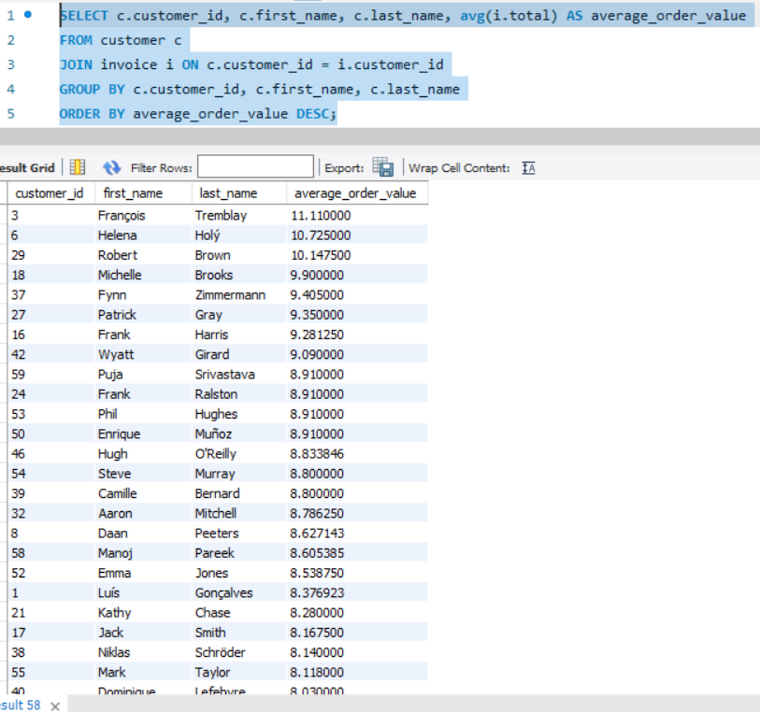

Based on the analysis of invoice and customer data, the following trends were identified:

- Some of the customers are more frequent buyers, with up to or maximum 18 purchases and minimum 4 purchases as per data or shown in the output snapshot.
- Average order values vary across customers, with top spenders averaging over 11.11 per invoice.
- Due to data limitations, we were unable to analyze preferred payment methods.

- What is the customer churn rate?
The churn rate refers to the percentage of customers who stopped purchasing over a specific period.
There are no user subscription details and no active/inactive users information mentioned in the given dataset.
However, let’s consider a cutoff period here as 3 months
Code:
WITH recent_buyers AS (
SELECT DISTINCT customer_id
FROM invoice
WHERE invoice_date >= DATE_SUB((SELECT MAX(invoice_date) FROM invoice), INTERVAL 3 MONTH)
),
all_customers AS (
SELECT customer_id FROM customer
)
SELECT (COUNT(ac.customer_id) - COUNT(rb.customer_id)) * 100.0 / COUNT(ac.customer_id) AS churn_rate_percent,
COUNT(ac.customer_id) AS total_customers, COUNT(rb.customer_id) AS active_customers,
(COUNT(ac.customer_id) - COUNT(rb.customer_id)) AS churned_customers
FROM all_customers ac
LEFT JOIN recent_buyers rb ON ac.customer_id = rb.customer_id;

Output of the query:
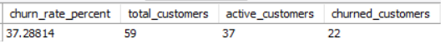

Insight from Output:
- Total Customers: 59
- Active Customers: 37
- Churned Customers: 22
- Churn Rate: 37.29%
- Calculate the percentage of total sales contributed by each genre in the USA and identify the best-selling genres and artists.
To calculate the percentage of total sales contributed by each genre we need to perform join on below tables:
- invoice for billing_country and total
- invoice_line for quantity, unit_price
- track for genre_id, unit_price
- genre for genre name
WITH GenreSales AS (
SELECT g.Name AS genre_name, SUM(il.Unit_Price * il.Quantity) AS genre_sales
FROM Invoice i
JOIN Invoice_Line il ON i.Invoice_Id = il.Invoice_Id
JOIN Track t ON il.Track_Id = t.Track_Id
JOIN Genre g ON t.Genre_Id = g.Genre_Id
WHERE i.Billing_Country = 'USA'
GROUP BY g.Name
),
TotalUSASales AS (
SELECT SUM(il.Unit_Price * il.Quantity) AS total_sales
FROM Invoice i
JOIN Invoice_Line il ON i.Invoice_Id = il.Invoice_Id
WHERE i.Billing_Country = 'USA'
),
GenreSalesPercent AS (
SELECT gs.genre_name, gs.genre_sales, ROUND((gs.genre_sales / ts.total_sales) * 100, 2) AS percent_of_total
FROM GenreSales gs, TotalUSASales ts
),
TopArtistPerGenre AS (
SELECT g.Name AS genre_name, a.Name AS artist_name, SUM(il.Unit_Price * il.Quantity) AS artist_sales,
ROW_NUMBER() OVER (PARTITION BY g.Name ORDER BY SUM(il.Unit_Price * il.Quantity) DESC) AS rn
FROM Invoice i
JOIN Invoice_Line il ON i.Invoice_Id = il.Invoice_Id
JOIN Track t ON il.Track_Id = t.Track_Id
JOIN Genre g ON t.Genre_Id = g.Genre_Id
JOIN Album al ON t.Album_Id = al.Album_Id
JOIN Artist a ON al.Artist_Id = a.Artist_Id
WHERE i.Billing_Country = 'USA'
GROUP BY g.Name, a.Name
)
SELECT gsp.genre_name, gsp.genre_sales, gsp.percent_of_total, tapg.artist_name AS top_artist
FROM GenreSalesPercent gsp
LEFT JOIN TopArtistPerGenre tapg ON gsp.genre_name = tapg.genre_name AND tapg.rn = 1
ORDER BY gsp.genre_sales DESC;

Here is the o/p of query:

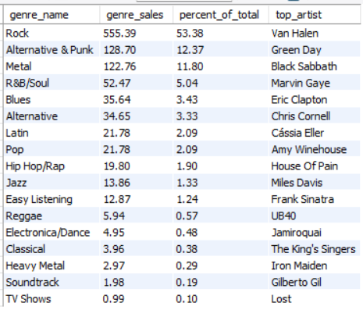

As shown in the result, in the USA market, the top-selling genre is Rock, contributing over 53.38% of total sales percentage. Other high-performing genres include Alternative & Punk and Metal.
Among artists, Van Halen ranks as the highest-grossing, followed by Green Day and Black Sabbath in the USA customer base.

- Find customers who have purchased tracks from at least 3 different genres
SELECT c.customer_id, c.first_name, c.last_name, COUNT(DISTINCT g.genre_id) AS genre_purchased
FROM customer c
JOIN invoice i ON c.customer_id = i.customer_id
JOIN invoice_line il ON i.invoice_id = il.invoice_id
JOIN track t ON il.track_id = t.track_id
JOIN genre g ON t.genre_id = g.genre_id
GROUP BY c.customer_id, c.first_name, c.last_name
HAVING COUNT(DISTINCT g.name) >= 3
ORDER BY genre_purchased DESC;

A total of 59 customers have explored 3 or more than that different genres, here is the sample o/p of the query.
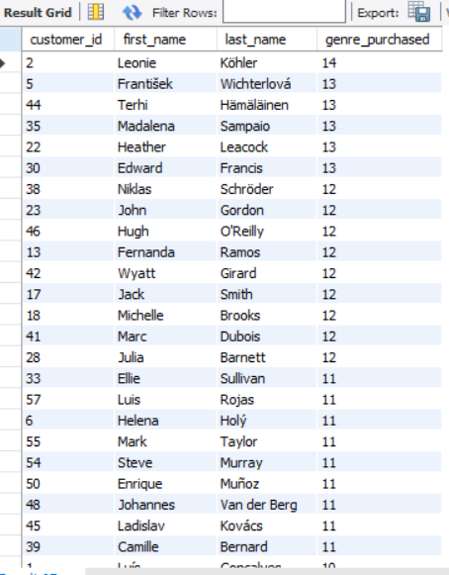

- Rank genres based on their sales performance in the USA
Here we have to calculate the total sales per genre from the USA country only. Then assign rank to genres by sales in descending order
SELECT g.name AS genre_name, SUM(il.unit_price * il.quantity) AS total_sales,
RANK() OVER (ORDER BY SUM(il.unit_price * il.quantity) desc) AS sales_rank
FROM invoice_line il
JOIN invoice i ON il.invoice_id = i.invoice_id
JOIN track t ON il.track_id = t.track_id
JOIN genre g ON t.genre_id = g.genre_id
JOIN album a ON t.album_id = a.album_id
JOIN artist ar ON a.artist_id = ar.artist_id
where i.billing_country = 'USA'
group by genre_name
order by total_sales desc;

O/p of the query:
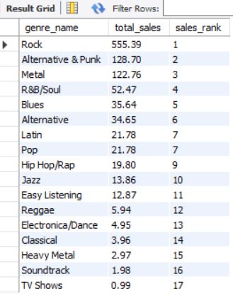
In USA Rock is the highest performing genre followed by Alternative & Punk and Metal.
- Identify customers who have not made a purchase in the last 3 months
To find customers whose last invoice date is older than 3 months from the most recent purchase in the given dataset.
SELECT c.customer_id, c.first_name, c.last_name, DATE(MAX(i.invoice_date)) AS LastPurchaseDate
FROM Customer c
JOIN Invoice i ON c.customer_id = i.customer_id
GROUP BY c.customer_id, c.first_name, c.last_name
HAVING MAX(i.invoice_date) < DATE((SELECT MAX(invoice_date) FROM invoice)) - INTERVAL 3 MONTH;

Here is the O/P of the query:
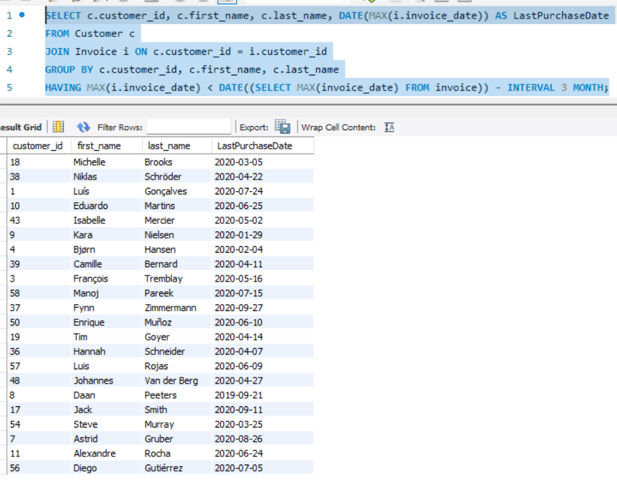

Subjective Questions

- Recommend the three albums from the new record label that should be prioritised for advertising and promotion in the USA based on genre sales analysis.

- Code:
SELECT a.album_id AS AlbumId, a.title AS AlbumTitle, ar.name AS ArtistName, g.name AS Genre, SUM(il.unit_price * il.quantity) AS AlbumSales FROM invoice i JOIN invoice_line il ON i.invoice_id = il.invoice_id
JOIN track t ON il.track_id = t.track_id
JOIN album a ON t.album_id = a.album_id
JOIN artist ar ON a.artist_id = ar.artist_id
JOIN genre g ON t.genre_id = g.genre_id
WHERE i.Billing_Country = 'USA'
GROUP BY a.album_id, a.title, ar.name, g.name
ORDER BY AlbumSales DESC
LIMIT 3;

- Output image of sql
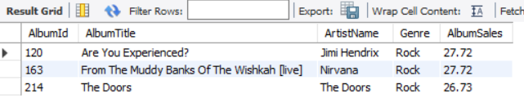
- Approach

  - Calculated total album sales by genre in the USA
  - Identified the top 3 revenue-generating genres
  - Filtered albums whose tracks belong to those top genres
  - Ranked albums by their individual sales in descending order
  - Selected the top 3 albums from those genres by using LIMIT

- Insights
  - The Rock genre is dominate in the USA market
  - Albums like: Are You Experienced?, From The Muddy Banks Of The Wishkah [live], The Doors have high traction in terms of sales.

- Recommendation
  - Prioritize advertising and promotion of these top 3 albums in the Rock genres.
  - Develop targeted marketing strategies e.g., social media ads (on facebook, instagram, etc.), genre-specific playlists, and merchandise collaborations to engage audiences and genre enthusiasts.

- Determine the top-selling genres in countries other than the USA and identify any commonalities or differences.

- Code
SELECT i.billing_country, g.name AS Genre, SUM(il.unit_price * il.quantity) AS TotalSales,
ROW_NUMBER() OVER (PARTITION BY i.billing_country ORDER BY SUM(il.unit_price * il.quantity) DESC) AS rnk
FROM invoice i
JOIN invoice_line il ON i.invoice_id = il.invoice_id
JOIN track t ON il.track_id = t.track_id
JOIN genre g ON t.genre_id = g.genre_id
WHERE i.billing_country != 'USA'
GROUP BY i.billing_country, g.name
ORDER BY i.billing_country, TotalSales DESC;

- Output image of sql
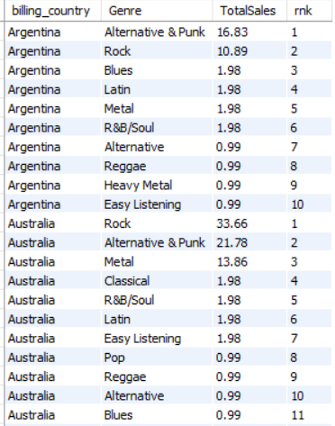
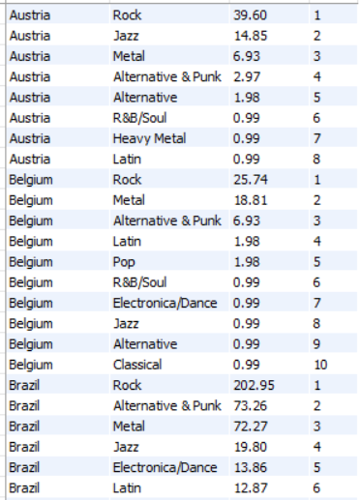
- The alternate way we can perform by assigning rank to each country and select only top most selling genre
Here's the revised SQL code that shows only the top-selling genre per country (excluding USA)
SELECT BillingCountry, Genre, TotalSales
FROM (
SELECT i.billing_country as BillingCountry, g.name AS Genre, SUM(il.unit_price * il.quantity) AS TotalSales,
ROW_NUMBER() OVER (PARTITION BY i.billing_country ORDER BY SUM(il.unit_price * il.quantity) DESC) AS rnk
FROM invoice i
JOIN invoice_line il ON i.invoice_id = il.invoice_id
JOIN track t ON il.track_id = t.track_id
JOIN genre g ON t.genre_id = g.genre_id
WHERE i.billing_country <> 'USA'
GROUP BY i.billing_country, g.Name
) AS ranked_genres
WHERE rnk = 1
ORDER BY TotalSales DESC;

- Output image of sql
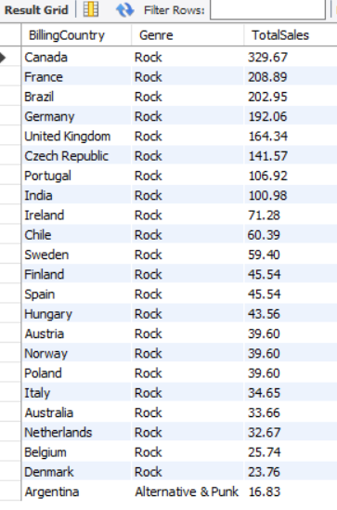
- Approach

  - Joined invoice i, invoice_line il, track t, and genre g
  - Excluded USA using WHERE i.billing_country != 'USA'
  - Aggregate sales SUM(i.unit_price * i.quantity) per genre in each country
  - Then ORDER BY total sales in descending to identify top genres per country

- Insights
  - Rock is the most consistently top-selling genre across multiple countries like Canada, France, Brazil, and so on
  - Argentina is the only exception, prefers Alternative & Punk genre
  - Sales volume high in Canada(329.67) and low in Argentina(16.83)

- Recommendations
  - Prioritize the Rock genre for international promotions, as it is the top-selling genre in almost all countries.
  - Collaborate with globally popular Rock artists to increase cross-country appeal and sales.
  - Explore Alternative & Punk campaigns in Argentina to cater to local tastes.
  - Launch or arrange events, shows for promotion and regional engagement

- Customer Purchasing Behavior Analysis: How do the purchasing habits (frequency, basket size, spending amount) of long-term customers differ from those of new customers? What insights can these patterns provide about customer loyalty and retention strategies?
To analyze the customer purchase behaviour lets check the very first invoice date or purchase date by checking the min() invoice_date
To analyze customer purchase behavior we will identify the very first or the earliest purchase date using the min() function on the invoice_date column.
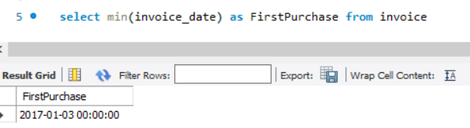
Now lets see the total purchase and minimum purchase date of each customer by grouping them
Code:
select customer_id, min(invoice_date) as FirstPurchase from invoice
group by customer_id
order by FirstPurchase asc

O/P of the query:

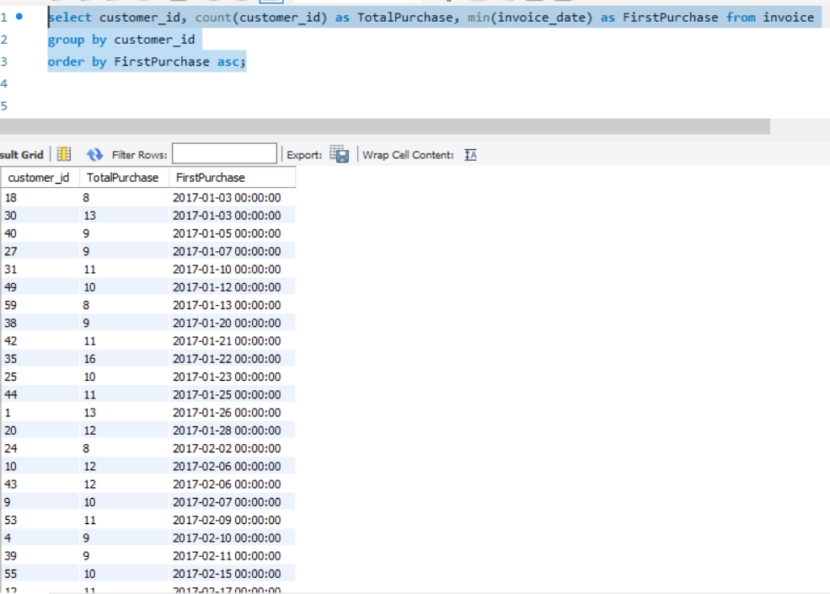

From the above data we got the minimum purchase date is - 2017-01-03.
Now next step is to find out the purchasing habits (frequency, basket size, spending amount) of long-term customers differ from those of new customers
By using the CTA (common table expression) we will analyze the purchase behaviour

WITH FirstPurchase as(
select customer_id, min(invoice_date) as FirstPurchase from invoice
group by customer_id
order by FirstPurchase asc
),
customer_type AS (
SELECT fp.customer_id,
CASE WHEN fp.FirstPurchase <= '2017-01-03' THEN 'Long-Term'
ELSE 'New'
END AS CustomerCategory
FROM FirstPurchase fp
),
purchase_behavior AS (
SELECT ct.CustomerCategory, i.customer_id,
COUNT(DISTINCT i.customer_id) AS PurchaseFrequency,
SUM(il.unit_price * il.quantity) AS TotalSpent,
AVG(il.unit_price * il.quantity) AS AvgBasketSize
FROM customer_type ct
JOIN invoice i ON ct.customer_id = i.customer_id
JOIN invoice_line il ON i.invoice_id = il.invoice_id
GROUP BY ct.CustomerCategory, i.customer_id
)
SELECT CustomerCategory, COUNT(PurchaseFrequency) as TotalCustomer, avg(PurchaseFrequency) AS AvgFrequency, AVG(AvgBasketSize) AS AvgBasketSize, AVG(TotalSpent) AS AvgTotalSpent
FROM purchase_behavior
GROUP BY CustomerCategory;

O/P of the query:

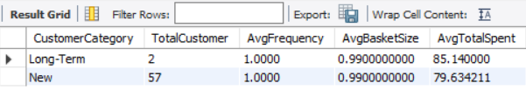
Visualization of above data using Bar Chart:
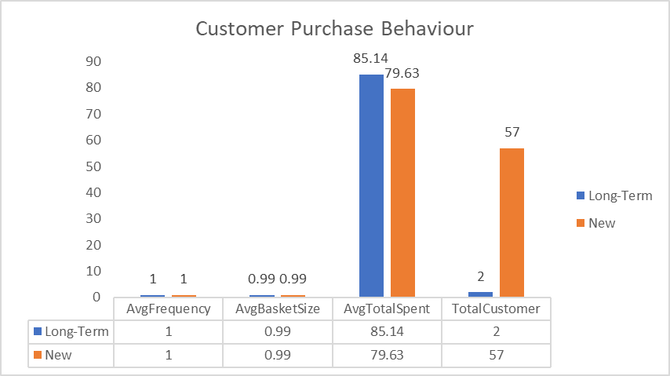

Approach
- Customers are categorized based on their first purchase date.
- We have observed customers have made multiple purchase
- Compared purchase frequency, basket size, and total spend.
- Aggregated results per customer category for comparison.

Insights
- Long-term customers:
  - Two long-term customers showed higher engagement, with an average spend of 85.14 above the overall average and increased purchase frequency.
  - Have larger average basket size, indicating deeper engagement.
- New customers:
  - Lower spend and less frequent, suggesting a need for better onboarding or value proposition.

Recommendations
- Offer subscription bundles or curated playlists to increase basket size over time.
- Reward long-term customers with loyalty programs and exclusive discount offers.
- Design welcome campaigns or onboarding discounts for new customers to boost retention.
- Analyze drop-off timelines for new customers to improve conversion to long-term.

- Product Affinity Analysis: Which music genres, artists, or albums are frequently purchased together by customers? How can this information guide product recommendations and cross-selling initiatives?
We can find out frequently purchased genres via common invoice id in genre, artists and album table
Code:
SELECT g1.Name AS Genre1, al1.title as Album1, ar1.name as Artist1, g2.Name AS Genre2, al2.title as Album2, ar2.name as Artist2, COUNT(DISTINCT il1.invoice_id) AS CommonInvoiceCount
FROM invoice_line il1
JOIN track t1 ON il1.track_id = t1.track_id
JOIN genre g1 ON t1.genre_id = g1.genre_id
JOIN album al1 ON t1.album_id = al1.album_id
JOIN artist ar1 ON al1.artist_id = ar1.artist_id

JOIN invoice_line il2 ON il1.invoice_id = il2.invoice_id AND il1.track_id <> il2.track_id
JOIN track t2 ON il2.track_id = t2.track_id
JOIN genre g2 ON t2.genre_id = g2.genre_id
JOIN album al2 ON t1.album_id = al2.album_id
JOIN artist ar2 ON al1.artist_id = ar2.artist_id

WHERE g1.Name < g2.Name
GROUP BY g1.Name, g2.Name, al1.title, ar1.name, al2.title, ar2.name
ORDER BY CommonInvoiceCount DESC;

O/P of the query:
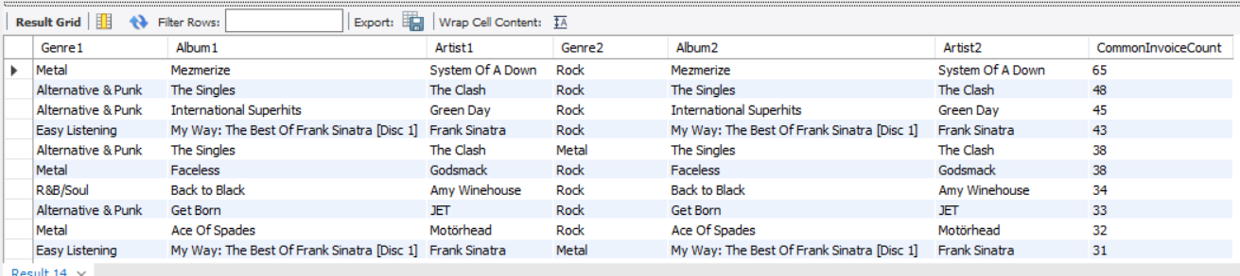
Approach:
- We self-join invoice_line, track, genre, album and artist table to find items purchased together within the same invoice but different track_id to find co-purchases..
- Compare Artist-Album pairs and count how many times they occur together in a purchase.
Recommendation:
- Create Buy-Together offer of top co-purchased genres or artists/albums
- Cross-selling based on user behaviour e.g. people also bought this together or complementary albums.
- Online purchase offer or discount on the app/website

- Regional Market Analysis: Do customer purchasing behaviors and churn rates vary across different geographic regions or store locations? How might these correlate with local demographic or economic factors?

Code:

- Customer Purchase Behavior by Country
SELECT country, count(i.customer_id) as TotalCustomerByCountry, sum(i.total) as TotalPurchase, SUM(i.total) / COUNT(DISTINCT c.customer_id) AS AvgSpendPerCustomer
FROM customer c
JOIN invoice i on c.customer_id = i.customer_id
GROUP BY country order by TotalPurchase desc;

O/P of the query:
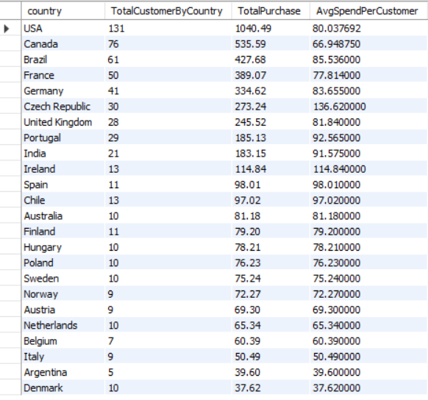

- Customer Churn Status by Country
To identify the churn status by country, we first determine the latest invoice date in the dataset. Using this as a reference date, we define the churn cutoff as 3 months prior to that date.

WITH InvoiceMaxDate AS (
SELECT MAX(invoice_date) AS LatestInvoiceDate FROM invoice
),
CustomerLastPurchase AS (
SELECT c.customer_id, c.Country, MAX(i.invoice_date) AS LastPurchaseDate
FROM customer c
LEFT JOIN invoice i ON c.customer_id = i.customer_id
GROUP BY c.customer_id, c.Country
),
CustomerChurnStatus AS (
SELECT clp.customer_id, clp.Country, clp.LastPurchaseDate, imd.LatestInvoiceDate,
CASE WHEN clp.LastPurchaseDate < DATE_SUB(imd.LatestInvoiceDate, INTERVAL 3 MONTH) THEN 'Churned'
ELSE 'Active'
END AS ChurnStatus
FROM CustomerLastPurchase clp
CROSS JOIN InvoiceMaxDate imd
)
SELECT Country, COUNT(customer_id) AS TotalCustomers,
SUM(CASE WHEN ChurnStatus = 'Churned' THEN 1 ELSE 0 END) AS ChurnedCustomers,
ROUND(SUM(CASE WHEN ChurnStatus = 'Churned' THEN 1 ELSE 0 END) / COUNT(customer_id) * 100, 2) AS ChurnRate
FROM CustomerChurnStatus
GROUP BY Country
ORDER BY ChurnRate DESC;

O/P of the query:
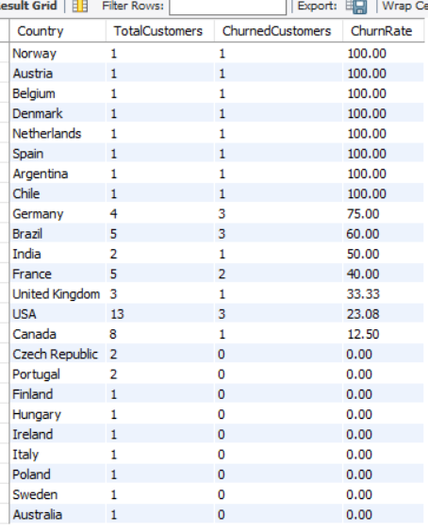
Data Visualization:
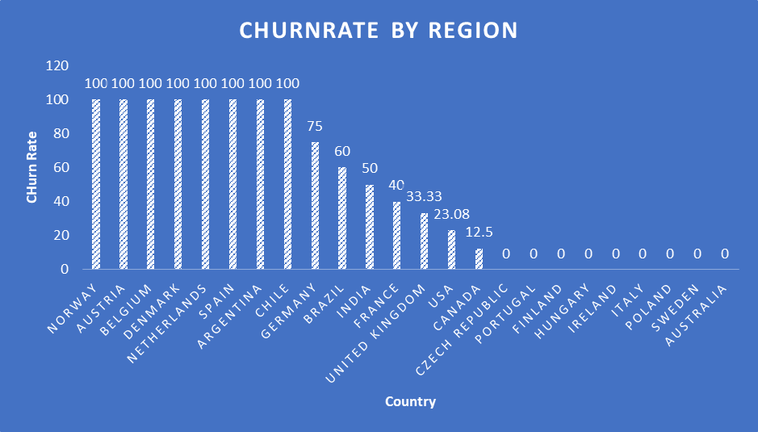

Approach:
- Extracted the maximum invoice date from the invoice table to identify the most recent customer activity in the dataset that is 2020-12-30
- We have taken 3 months here to define the churn cutoff. Subtracted 3 months from the latest invoice date to establish a cutoff point for identifying inactive customers.
- Using a LEFT JOIN, we grouped customers into Active and Churned category
  - Active – Made a purchase on or after the cutoff date.
  - Churned – No purchases in the last 3 months.
- Group by Country: Aggregated results to calculate churned vs. active customer counts per country, and derived the churn rate as a percentage.

Insight:
- High churn risk in countries like Norway, Austria, Belgium, Denmark, Netherland show 100% churn, though they each have only 1 customer.
- Countries like Germany (75%), Brazil (60%), India (50%), and France (40%) have multiple customers and notable churn, suggesting potential engagement issues or competition.
- USA and Canada with high Customer base 13 and 8 respectively, shows low churn rate (23%) & (12.5%)
- Countries like the Czech Republic, Portugal, and several others show 0% churn rate with low customer counts.
Recommendation:
- Build customer engagement plan or strategy to reduce churn & improve retention
- Set up automated email/SMS, and WhatsApp blast sequences for customers who have not made a purchase in the last 3 months.
- Deploy localized marketing campaigns based on country-specific churn rates
- Customer feedback survey form to understand what went wrong and scope of improvement. Ask why they stopped buying (e.g. price, product, experience)
- Collect the Testimonials from the regular customers and highlight/utilize them for brand promotion activities, Website and social media platforms for brand awareness
- Design region-specific loyalty programs that offer perks such as early access to new releases, birthday discounts, and exclusive rewards. These incentives not only encourage repeat purchases but also strengthen customer trust and long-term brand loyalty.

- Customer Risk Profiling: Based on customer profiles (age, gender, location, purchase history), which customer segments are more likely to churn or pose a higher risk of reduced spending? What factors contribute to this risk?
In the customer table the age, gender information is not available but we can evaluate the risk profiling by country and total purchase
Code:
WITH CustomerProfiling as (
SELECT c.customer_id, c.first_name, c.last_name, c.Country, MAX(i.invoice_date) AS LastPurchaseDate,
DATEDIFF('2020-12-30', MAX(i.invoice_date)) AS DaysSinceLastPurchase,
COUNT(i.invoice_id) AS TotalPurchases,
SUM(i.Total) AS TotalSpent
FROM Customer c
JOIN Invoice i ON c.customer_id = i.customer_id
GROUP BY c.customer_id, c.first_name, c.last_name, c.Country
)
SELECT customer_id, Country, first_name, last_name, TotalPurchases, TotalSpent, LastPurchaseDate, DaysSinceLastPurchase,
CASE WHEN DaysSinceLastPurchase > 180 THEN 'High'
WHEN DaysSinceLastPurchase between 90 AND 180 THEN 'Moderate'
ELSE 'Low'
END as RiskLevel
from CustomerProfiling
ORDER BY DaysSinceLastPurchase DESC;

O/P of the query:
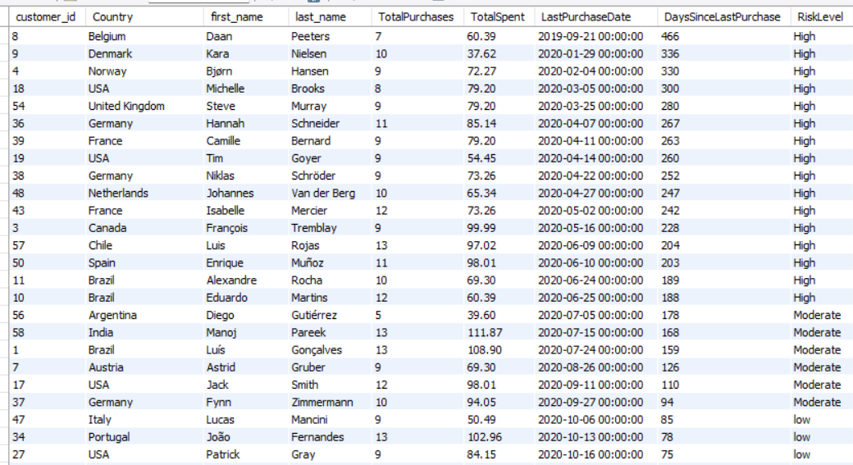
Data Visualization:
1. Bar Chart - Number of Customers by Risk Level
To understand how many customers fall into each risk category.
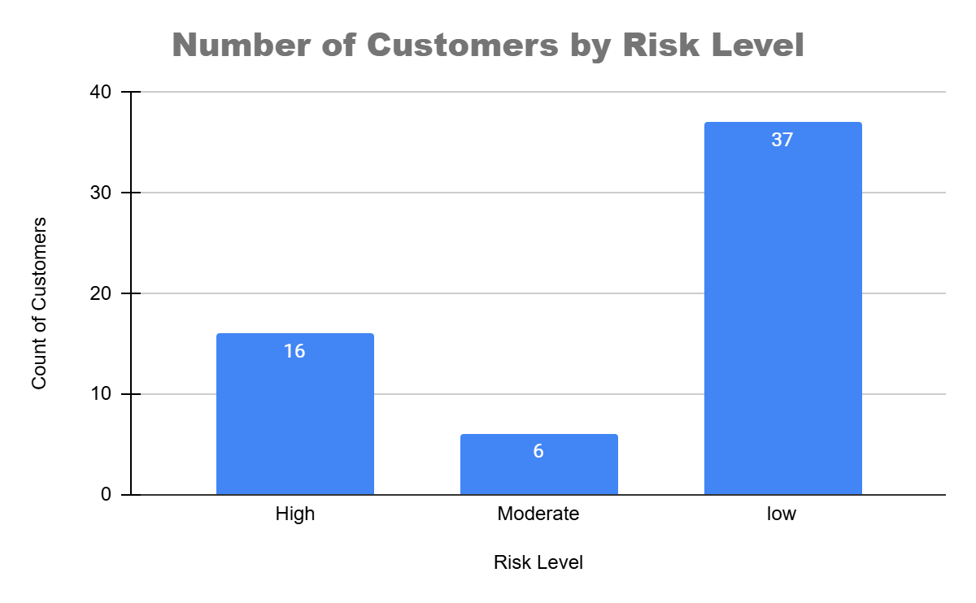
2. Stacked Bar Chart - Risk Level by Country
Shows customer risk distributed across countries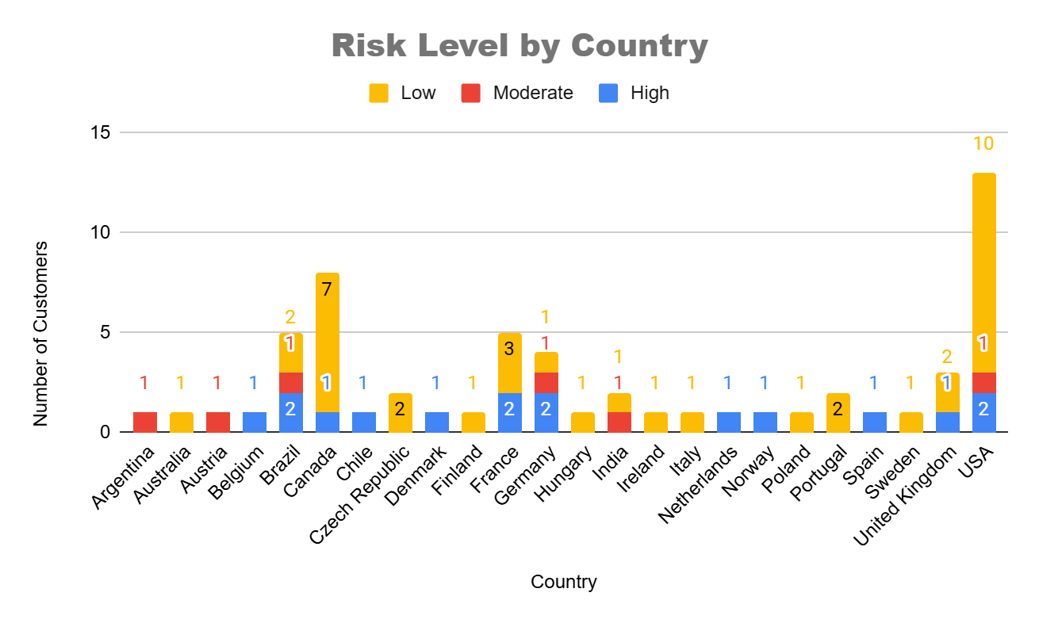
3. Scatter Plot – Days Since Last Purchase vs TotalSpent
To know the Correlation between inactivity and spending
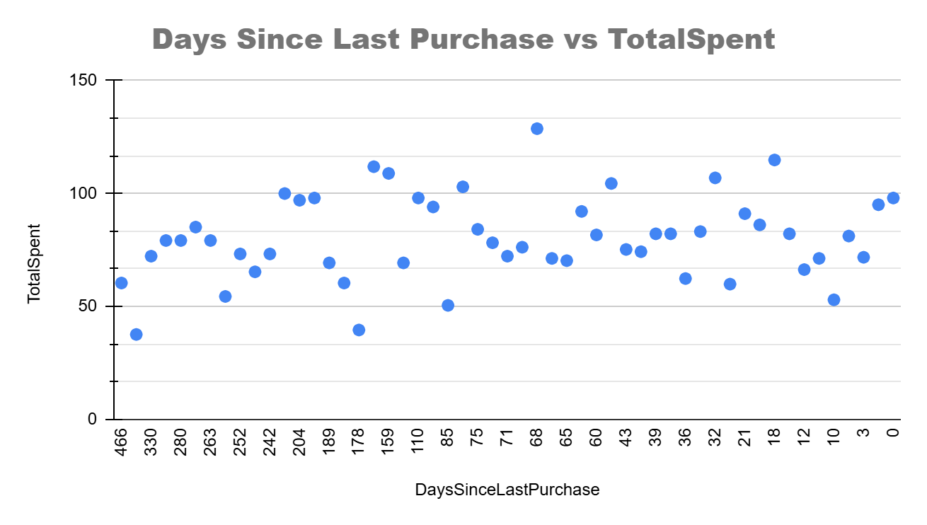
Approach:
- Calculated Last Purchase Date for each customer using MAX(i.InvoiceDate)
- Derived Days Since Last Purchase using DATEDIFF() from a fixed date 2020-12-30 to standardize churn risk measurement
- Aggregated TotalPurchases and TotalSpent per customer to measure engagement and profitability
- Segmented customers based on recency or last purchased and spend
Each customer was profiled by:
- Calculating DaysSinceLastPurchase
- Summing TotalSpent and TotalPurchases
- Tagging customers into High, Moderate, or Low risk based on purchase inactivity.
Insights:
- As per the output, the High Risk Customers are the customers with > 180 days i.e. almost 6 months since their last purchase and declining purchase frequency are at risk of churning. Example:
  - Daan Peeters (Belgium) – 466 days since last purchase
  - François Tremblay (Canada) – 228 days since last purchase
  - Enrique Muñoz (Spain) – 203 days since last purchase
The customers have low total spending and few purchases are considered under low ROI segment for example Robert Brown or Diego Gutiérrez (low spenders + inactive)
Some customers have high purchases but have not returned in over 200 days (e.g. Eduardo Martins, John Gordon). These customers need reactivation efforts.
Countries like USA, Germany, and Brazil shows both high engagement and long inactivity periods possible because lack of marketing or campaigns
Recommendations:
- Target High-Risk Customers (16) with Re-engagement Campaigns:
- Personalized emails with discounts, music recommendations, or loyalty points.
- Especially customers with previous spending potential
- Country-Specific Offers:
- Focus retention strategies in Belgium, Denmark, Norway, USA, UK, Germany, France, Netherlands, Canada, Chile, Spain, and Brazil where high-risk users cluster.
- VIP Loyalty Program for Low-Risk Customers:
- Offer incentives to maintain high frequency and recency.
- Monitor Moderate Risk(6) Zone. These are ideal candidates for proactive engagement before churn occurs.
___________________________________________________________________
- Customer Lifetime Value Modeling: How can you leverage customer data (tenure, purchase history, engagement) to predict the lifetime value of different customer segments? This could inform targeted marketing and loyalty program strategies. Can you observe any common characteristics or purchase patterns among customers who have stopped purchasing?

Code:
WITH CustomerLifetime AS (
SELECT c.customer_id, c.first_name, c.last_name, c.Country, MIN(DATE(i.invoice_date)) as FirstPurchaseDate , MAX(DATE(i.invoice_date)) AS LastPurchaseDate,
DATEDIFF('2020-12-30', MAX(i.invoice_date)) AS DaysSinceLastPurchase,
COUNT(i.invoice_id) AS TotalPurchases,
SUM(i.Total) AS TotalRevenue, ROUND(SUM(i.Total) / COUNT(i.invoice_id), 2) as AvgOfPurchase,
ROUND(SUM(i.Total) / DATEDIFF(MAX(i.invoice_date), MIN(i.invoice_date)), 2) AS RevenuePerDay
FROM Customer c
JOIN Invoice i ON c.customer_id = i.customer_id
GROUP BY c.customer_id, c.first_name, c.last_name, c.Country
),
CustomerSegments AS (
SELECT *, CASE WHEN TotalRevenue >= 100 THEN 'High Value'
WHEN TotalRevenue BETWEEN 60 AND 100 THEN 'Medium Value'
ELSE 'Low Value'
END AS ValueSegment,
CASE WHEN DaysSinceLastPurchase > 180 THEN 'Churned'
ELSE 'Active'
END AS Status
FROM CustomerLifetime
)
SELECT * FROM CustomerSegments
ORDER BY TotalRevenue DESC;

Output of the query:
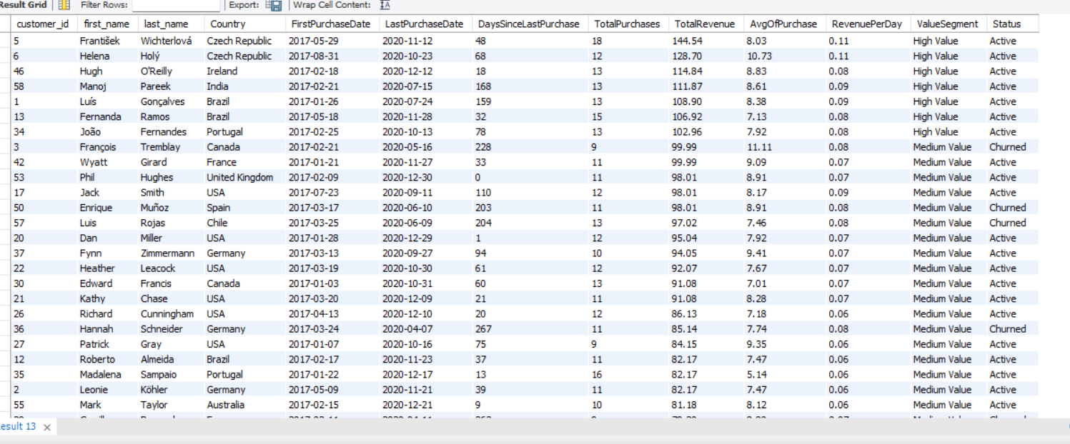

Data Visualization:

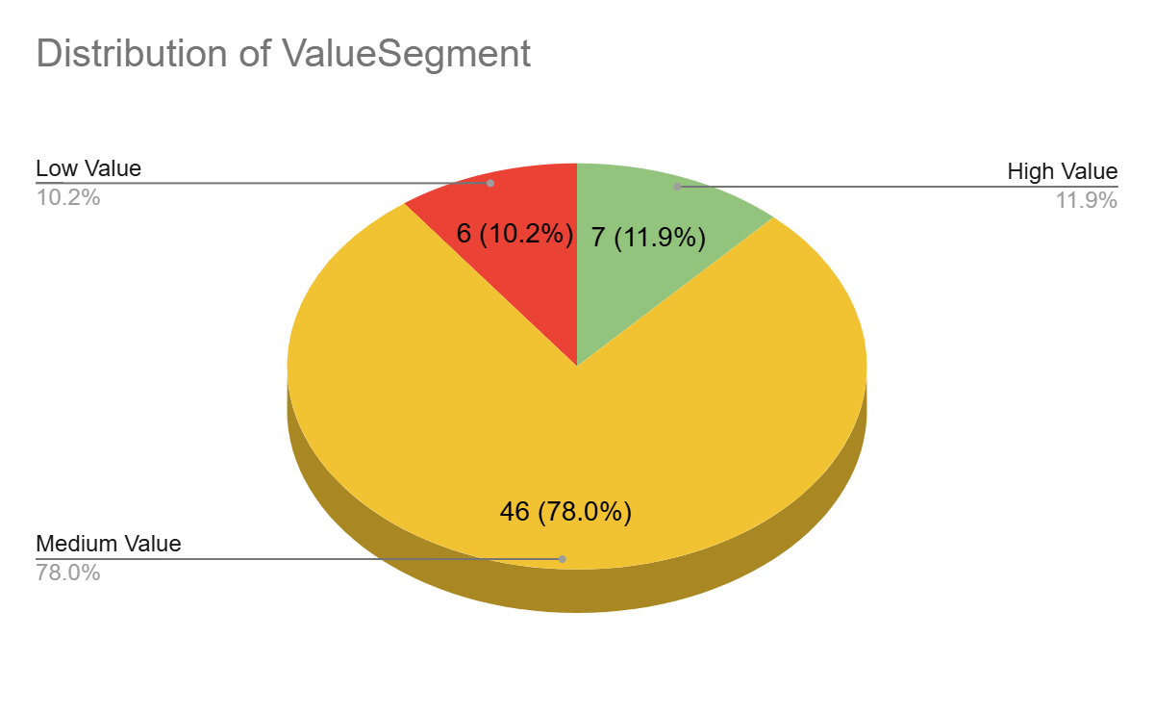

Approach:
- Tenure was calculated using FirstPurchaseDate and LastPurchaseDate
- Engagement is captured via TotalPurchases and RevenuePerDay
- Customers were segmented into High/Medium/Low Value based on total revenue
- Churn was defined as customers with no purchases in the last 180 days
- The final dataset enables spotting risk patterns and loyalty behavior

Insights
- High Value Customers (TotalRevenue > 100) tend to have:
  - Higher frequency of purchases is 18 orders
  - More recent purchase activity (DaysSinceLastPurchase < 100)
  - Higher Avg Purchase is 10.73 and Revenue per Day is 0.11
- Churned Customers are mostly in the Medium or Low Value segments.
  - They have not purchased it for 200+ days.
  - Many churned customers have Avg. RevenuePerDay < 0.08.
- Geographical Pattern:
  - Customers from Belgium, Denmark, Norway, United Kingdom, USA, Germany, and France etc. appear frequently in the churned list.
  - India, Brazil, Czech Republic, Portugal and Ireland show high-value, active customers.
Recommendations:
- Segment customers into Platinum, Gold, and Silver based on their lifetime value and offer increasing rewards and perks. This motivates lower-value customers to climb tiers.
- Use predictive models to identify which churned customers are most likely to return. Offer them personalized win-back emails, discounts, or curated playlists.
- Reward customers not just for purchases but for non-monetary engagements (e.g., app logins, playlist creation, shares). This builds brand affinity and contributes indirectly to customer lifetime value.
- Offer occasional price incentives to customers with moderate CLV to encourage upsell/cross-sell, but avoid unnecessary discounts to high CLV customers who would have purchased anyway.
- Geo-Based Custom Marketing or regional discounts where average CLV is lower.
- Subscription model (monthly/annually) introduction to improving customer lifetime value stability and reducing churn.
_____________________________________________________________

- If data on promotional campaigns (discounts, events, email marketing) is available, how could you measure their impact on customer acquisition, retention, and overall sales?
Analyzing promotional campaign impact is important for retention strategy and ROI-driven decisions in marketing. Let's assume we execute a promotional campaign for 15 days i.e. from 16th Jan 2020 to 31st Jan 2020
To see the campaign impact we consider the total sales and customers as a KPI over here and by performing below query we can check the result:
SELECT 'Pre-Campaign' AS Period, COUNT(DISTINCT customer_id) AS UniqueCustomers, SUM(total) AS TotalRevenue
FROM Invoice
WHERE invoice_date BETWEEN '2020-01-01' AND '2020-01-15'
UNION ALL
SELECT 'Post-Campaign' AS Period, COUNT(DISTINCT customer_id), SUM(total)
FROM Invoice
WHERE invoice_date BETWEEN '2020-01-16' AND '2020-01-31';

Output of the query:
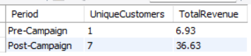
From the above result we can observe the increment in unique customers and growth in sales during the post campaign period.
We can also group users who joined or purchased during the campaign and track their behavior over time.
Customer Cohort Tracking
WITH CampaignCohort AS (
SELECT customer_id, MIN(invoice_date) AS FirstPurchaseDate
FROM Invoice
WHERE invoice_date BETWEEN '2020-01-16' AND '2020-01-31' -- Campaign period
GROUP BY customer_id
)

SELECT MONTH(i.invoice_date) AS Month, COUNT(DISTINCT i.customer_id) AS ActiveCustomers, SUM(i.total) AS MonthlyRevenue
FROM Invoice i
JOIN CampaignCohort c ON i.customer_id = c.customer_id
GROUP BY MONTH(i.invoice_date)
ORDER BY Month;

Output of the query:
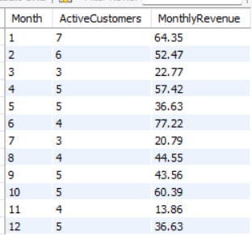

To track the user journey/flow use the UTM tags, email clicks event, referral sources, etc., to attribute conversion.
In the absence of actual campaign data, we are unable to assess the Campaign Conversion Funnel. With the data, we could have derived more actionable insights like:
- What percentage of revenue comes from users acquired during campaigns?
- Are churn rates lower for users brought in via personalized campaigns?
- Which campaigns have higher churn after first purchase?
- Did the event campaigns boost repeat sales or only spike one-time revenue?
- Which campaign types discounts, events, email or marketing drive the most repeat purchases?
Recommendations:
- Run A/B testing for campaign versions and compare impact.
- Focus on engagement campaigns, these often yield higher retention than just discounts.
- Compare retention of campaign-acquired customers vs. organic signups to build the retention strategy

- How would you approach this problem, if the objective and subjective questions weren't given?
If the objective and subjective questions were not given then my first step would be to explore the database, understand the schema, and structure of the dataset by getting familiar with the data
- Understand the Business Context
  - Chinook is a digital music store selling tracks/albums
  - It sells tracks and albums, involving customers, invoices, tracks, albums, artists, employees, genres, playlist, etc.
  - No specific problem statement provided
- Explore the dataset
  - Inspect 11 tables relationships: Customer, Invoice, Track, Genre, Album, Artist, Mediatype, Playlist, Employee, etc.
  - Identify primary KPIs: Revenue, purchase frequency, customer count, genre/artist performance, etc.
- Formulate meaningful business questions
  - Who are the top-spending customers?
  - Which genres generate the most revenue?
  - Which customers are inactive (churned)?
  - Which regions/countries perform best?
  - What is the average basket size?
  - Best-selling albums, genres, underperforming items
- Analyze key customer, product metrics and usage pattern
  - Customer Segments: High to Low, frequent buyers, new v/s returning users
  - Product Segments: Best-selling albums, genres, underperforming items
  - Churn Prediction: Based on last purchase date, frequency
- Communicate Insights Through Visualization
  - sales by year/region
  - Customer segmentation visuals
  - Revenue trend charts
  - Geographic performance (map view)
- Based on findings provide recommendations
  - Localize promotions for high-churn regions
  - Improve targeting for campaigns
  - Recommend loyalty programs, discounts and offers
  - Provide playlist or bundle frequently purchased genres

- How can you alter the "Albums" table to add a new column named "ReleaseYear" of type INTEGER to store the release year of each album?
The table “album” currently have only 3 fields album_id, title, and artist_id
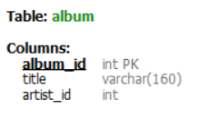
to add a new column named "ReleaseYear" of type INTEGER we have to write below SQL query:
ALTER TABLE album
ADD COLUMN ReleaseYear INTEGER;

Then as per the album title we will have to update the values in the individual record using below query:

UPDATE album
SET ReleaseYear = 2003
WHERE title = 'Balls to the Wall';

- Chinook is interested in understanding the purchasing behavior of customers based on their geographical location. They want to know the average total amount spent by customers from each country, along with the number of customers and the average number of tracks purchased per customer. Write an SQL query to provide this information.
Code:
SELECT c.country, COUNT(DISTINCT c.customer_id) AS TotalCustomers, ROUND(SUM(i.total) / COUNT(DISTINCT c.customer_id), 2) AS AvgTotalSpentPerCustomer,
ROUND(COUNT(it.track_id) * 1.0 / COUNT(DISTINCT c.customer_id), 2) AS AvgTracksPerCustomer
FROM customer c
JOIN invoice i ON c.customer_id = i.customer_id
JOIN invoice_line it ON i.invoice_id = it.invoice_id
GROUP BY c.country
ORDER BY AvgTotalSpentPerCustomer DESC;
Output of the query:
